Terms of Reference
Title / Name of the Role: | Save the Children – Centre Evidence and Learning Team – Information Management Consultant
Owner: | Ali Bulut Aksoy – OHT Evidence and Learning Advisor; ali.aksoy@savethechildren.org
Sponsor: | - Linda Steinbock – OHT Head of Evidence and Learning  - Roy Hanna – Director of Data and Analytics
Objectives: | - Review Country Office Information Flows and build a standard Humanitarian Information Flow in alignment with MEAL in Emergencies (MiE) Workflow, connecting frontline data collection tools with SCI’s IPTT tools  - Collaborate with Centre and Country Office Teams to Develop Standardized Monitoring and Tracking formats for Information Management in Country Offices  - Hunt for past data available working with centre PQI E&L
Duration of the Consultancy: | 4 months – Full time
Working Modality: | Remote / Online – If based in UK – SCI Centre Office can be used
Travel Requirement: | None

Contents
Acronyms 1
Summary / Background: 2
Objectives: 3
Deliverables: 4
Scope: 4
Timeline: 4
Resources and Constraints: 4
Stakeholder Engagement: 4
Annex 1 – MEAL Language Theoretical Discussion 5

Acronyms
CO | Country Office
MEAL | Monitoring, Evaluation, Accountability and Learning
E&L | Evidence and Learning
IM | Information Management
OHT | One Humanitarian Team
SC/I | Save the Children / International
PQI | Program Quality & Impact
SCHP | Save the Children Humanitarian Plan
MiE | MEAL in Emergencies
RACI | Responsible, Accountable, Consulted and Informed
IPTT | Indicator Performance Tracking Table
PRIME | Project Reporting Information Management and Evidence System

Summary / Background:
This consultancy is commissioned to address the critical need for enhanced information management within our Country Offices, operating in humanitarian and developmental contexts. The consultant is tasked with bridging the gaps in our current information flow and data management systems to establish a coherent, efficient, and industry-aligned practice. The goal is to refine data collection, storage, and analysis processes, and to forge a unified framework that enhances coordination between Monitoring, Evaluation, Accountability, and Learning (MEAL) and Programmatic teams
It's crucial to recognize existing initiatives in information management and reporting, particularly those targeting various stages of the MEAL workflow, including data collection platforms, indicator performance tracking, and project management reporting (e.g., PRIME). However, there is a notable gap between these stages (as illustrated in the diagram below) where activities such as data cleaning, transformation, and management take place. Country offices have expressed the need for a digitalized information management system in this area. While implementing a comprehensive system in the short term may not be feasible, the consultant hired for this task is expected to assess Country Office systems and develop procedures, a standardized workflow, and templates for databases and trackers.

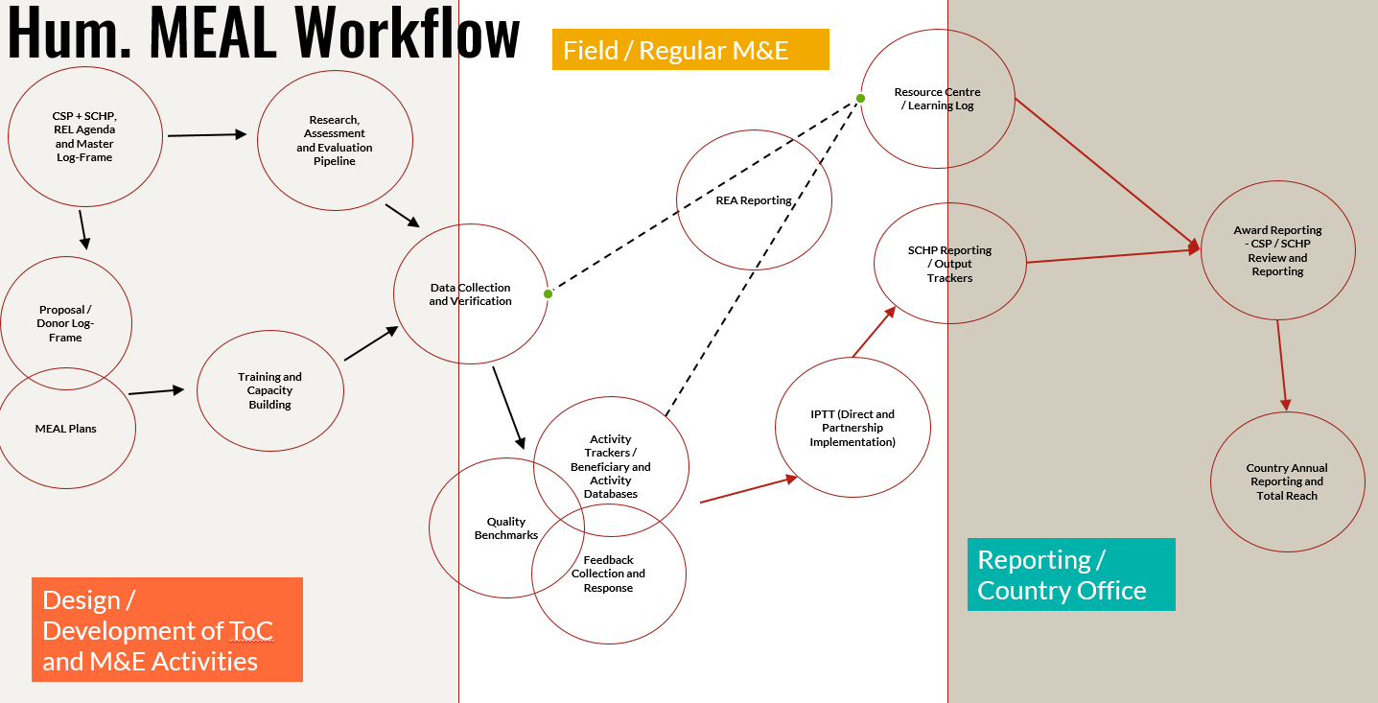

Objectives:
- Standardize Information Flow
- Conduct a detailed review of existing information management practices in Country Offices.
The consultant will thoroughly examine how information is currently handled in both Humanitarian and Development Country Offices. It's crucial to highlight that this information setup is not widely documented across offices. Therefore, the consultant will need to investigate and grasp how information is managed, including the systems and tools in place. The flow should also make references to other data initiatives with linkages how they contribute or can support to the different stages of the flow.
- Develop a standardized Humanitarian and Development Information Flow, incorporating a RACI matrix to delineate roles and responsibilities clearly.
The goal is to pinpoint areas where current practices can be enhanced and create a standardized Humanitarian and Development Information Flow that aligns with the MiE MEAL Workflow. This involves establishing distinct roles and responsibilities at each stage, from data collection to management, and extending to donor and SCI Centre reporting.
- Map current processes, identify bottlenecks, and recommend improvements for alignment with the MEAL in Emergencies (MiE) Workflow.
The work includes mapping out information flow processes, identifying bottlenecks, and recommending improvements to ensure efficient and effective data management aligned with organizational objectives. It should include a detailed RACI that lays out which function is supposed to do in each step of the flow, and how MEAL and Program / Operation teams should be engaging with each other and collaborate.

- Define requirements for Monitoring and Tracking Systems

- Collaborate with the Data & Analytics and MEAL teams to define requirements for standardized tools such as Activity Trackers and Beneficiary Databases:
The consultant will collaborate closely with the Data & Analytics team and the MEAL department to define requirements for standardized tools such as Activity Trackers and Beneficiary Databases. This includes designing requirements for systems that can efficiently monitor humanitarian and development activities, track progress, and handle beneficiary information to connect existing frontline data systems (especially data collection tools) and aggregate-level IPTT tools (SCI’s tool for this is PRIME). The intention is to create templates that could potentially serve as the groundwork for a comprehensive global digital information management system in the future, compatible with various data initiatives within the organization. This effort should directly align with the upcoming objective focused on establishing a standardized MEAL language for Country Offices.
- Ensure these systems facilitate the storage, transformation, management, and analysis of data for improved decision-making and reporting.
It's crucial to recognize existing initiatives in information management and reporting, particularly those targeting various stages of the MEAL workflow, including data collection platforms, indicator performance tracking, and project management reporting (e.g., PRIME). However, there is a notable gap between these stages (as illustrated in the diagram above) where activities such as data cleaning, transformation, and management take place. Country offices have expressed the need for a digitalized information management system in this area. While implementing a comprehensive system in the short term may not be feasible, the consultant hired for this task is expected to assess Country Office systems and develop procedures, a standardized workflow, and templates for databases and trackers.
- Looking at ways at minimizing duplication between Strategy Milestone and Humanitarian Plan Reporting
The consultant is anticipated to propose recommendations and refine standard formats to support harmonization of efforts between Strategy Milestone and Humanitarian Plan reporting. This entails examining the indicators reported by Country Offices and finding ways to harmonize their data management and transformation processes.
- Establish a standard MEAL language
- Utilize standard indicators to create a common MEAL language across databases, trackers, and tools, as detailed in Annex 1.
Building on the standard indicators, it is expected that the standard indicators can be used as a common MEAL language in Information Management databases, trackers and tools that links up different data points for holistic information management
- Data Retrieval and Analysis

  - Work with the Program Quality and Innovation (PQI) E&L team, and Data and Analytics team to locate and analyse historical data.
The consultant is expected to engage with the SCI Centre E&L / MEAL teams to collect historical data available to centre staff, and transform them to be aggregated under Standard Humanitarian or / Global Indicators.

Deliverables:
- A standard information flow model for Save the Children
- Standardised information management databases for Country Offices that are aligned with the existing systems of SCI, including data collection tools (Kobo/CommCare) and IPTT tools (PRIME)
- Training modules for MEAL / E&L personnel on information flow and standard tools.
- Consolidated historical data for Save the Children Centre Office

Scope:
The scope for the consultancy will cover all Country, Response and Member Offices within the organization's global network. The consultant will engage with each office to the extent necessary to achieve the standardization of information management practices.

Timeline:
A detailed timeline will be provided upon commencement, with milestones for each deliverable. The consultancy is expected to be completed within four months from the start date.

Resources and Constraints:
The consultant will have access to existing data, tools, and the cooperation of relevant departmental teams. Budgetary and time constraints will be outlined in the full contract.

Stakeholder Engagement:
The consultant will report to Roy Hanna, Director of Data and Analytics, with close collaboration and supervision by Ali Aksoy, Humanitarian Evidence & Learning Advisor. The consultant will work in collaboration with Country Office teams, Data & Analytics, and MEAL departments. Clear communication channels will be established

Annex 1 – MEAL Language Theoretical Discussion
Owner: Ali Bulut Aksoy – OHT Evidence and Learning Advisor; ali.aksoy@savethechildren.org
Taken from the “draft SCI Knowledge Management Guidance”

So far, we have discussed certain opportunities that can come through better SharePoint management, tags, and structured information flow. However, still none of those addresses the gap around what makes those systems talk with each other and points out the missing link. We would like to name this missing link as common “MEAL Language” which would facilitate the communication of different platforms, datasets, frameworks and reporting processes. In this case, we would like separate the process of establishing a MEAL Language into two, by first looking at what standardization means for operational MEAL, and how a potential MEAL language can look like.

Standardization
One of the big tasks ahead of us is the overall standardization in M&E in humanitarian operations as the Humanitarian Evidence and Learning Team and alignment with development teams. Accordingly, on different levels of the organization – we suffer from the fact that the indicators and their methodologies being used differs to an extent that comprehensive reporting on our impact on children is virtually impossible and limit it to basic beneficiary reporting. Possible standardization also offers couple of exciting solutions to our overall data management issues, and harmonization with the global frameworks such as the Save the Children Humanitarian Plan (SCHP). Therefore, by standardizing the indicators, first we will spend fewer efforts on data entry and management, and focus more on verification and data quality, and will be able to provide an overall picture of our work across movement.

As the Humanitarian Evidence and Learning team, we want to advocate the standardization through Save the Children Humanitarian Plan (SCHP) – Standard Indicators¹¹, through setting up standard measurement approaches, tools and indicators for the overall humanitarian operations in country offices. Accordingly, we aim to advocate the incorporation of these sets of indicators through the entire information flow of implementation, facilitating the easy communication of data from bottom to up, and understand our wider impact. In following sections, we discuss and try to offer solutions on how the incorporation of standard indicators on different levels is possible, how those entire efforts can contribute to the centralization and standardization of information.

On a different level – we plan building on the increased digitalization efforts in the movement, as we aim to incorporate set tools within Save the Children Kobo and Commcare country office accounts as default, ensuring the easy access of field personnel. If such standardization of formatting in account level can be done, likely the big data approaches can even communicate with most granular datasets in the future. This would also inherently bring automatic standardization in measurement methods, and allow better consolidation for outcome level indicator data.

Regardless whether we have standard mandatory tools or not, at least on country office levels, we strongly encourage senior MEAL personnel and PDQ teams to cooperate on how standardization can be done. Often, these efforts might be perceived with the risk of copy paste programming, which holds truth to some extent, and thus pushed back my thematic advisors in implementation level. However, this risk can be mitigated by using a MEAL language while keeping tailored approaches on ground, but translating and transferring information from tailored or donor indicators to standard indicator codes by labelling the entire data points.

MEAL Language
One of the potential solutions to link up different data points to each other in the country office could be developing a MEAL language (e.g., a coding system). It can translate and facilitate the communication of information and data from one dataset to another, linking up different donor log-frames with IPTTs to Output Trackers, or even Feedback and Reporting Databases. We think there are three potential formats (PRIME – SCHP – Donor Indicator Codes) that can be used to create a common MEAL language in our movement. This language can likely work along with Source of Fund codes (e.g., 99900XX) and country response codes (e.g, SYR-CF-19) as most of the information and data are archived on project basis due to the reporting requirements to donors.

In a country office level - once databases or data consolidation tools starts to use the standard language and unique identifiers, Excel or Power Query type of tools can potentially be used to link up datasets based on the reference points. Moreover, when we think about a bigger picture such approach can be used to link up data points beyond output or outcome indicators, looking at quality benchmark results or Feedback from beneficiaries, information that can provide narrative for the numbers we report. In wider database management approach, and with the aim of making a sense of big data, the coding approach is quite similar to the taxonomy and labelling approach that is suggested for overall archiving and communication systems in earlier sections of this document. For example – in wider consolidation databases in a country office – the use of MEAL code can look like below that is similar to a very common archiving model that is used by Kobo, Commcare, Query, SPSS, Power BI and many other data collection and processors.

Example Analysis Framework - below

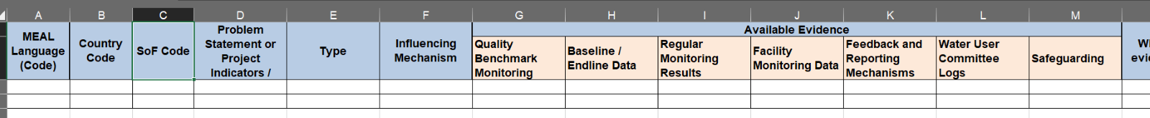
There can be two types of utilization of such approach:

- Single Database: We can use the indicator codes or namely the “MEAL language” to bind entire data points (in one database) to each other allowing bringing any quantitative and qualitative evidence forth when wider analysis is required.
- Multiple Databases: As the single database approach would require a wide transformation of the overall systems, the country offices can adapt the approach as per the level of effort they can put into this, or the extent of the data they want to bind to each other. Accordingly, they can bind most important findings rather than binding entire datasets together, and likely have the coding incorporated within separate databases (e.g., Feedback, QB Monitoring).
PRIME Indicator Codes (Centralized Approach)
PRIME system assigns unique IDs to each indicator that entered to the database (keeping in mind that everyone can add indicators) by the teams. Accordingly, the approach can potentially utilize the PRIME codes for the overall MEAL language in operational MEAL, and adapt the systems. Considering that the PRIME system’s vision is to be binding many systems together, having those codes already incorporated within field level could ease its implementation in the longer run. If the country office or upper levels of the organization decide to use the IDs – they will also have to deal with a long code (E.g., PRIME ID / Code - IN00002828) that doesn’t necessarily give hints what the indicator is about (e.g., SYR-CF-19.OHT.H1). Therefore, further evaluation is needed to understand how these codes will fit into the MEAL language.
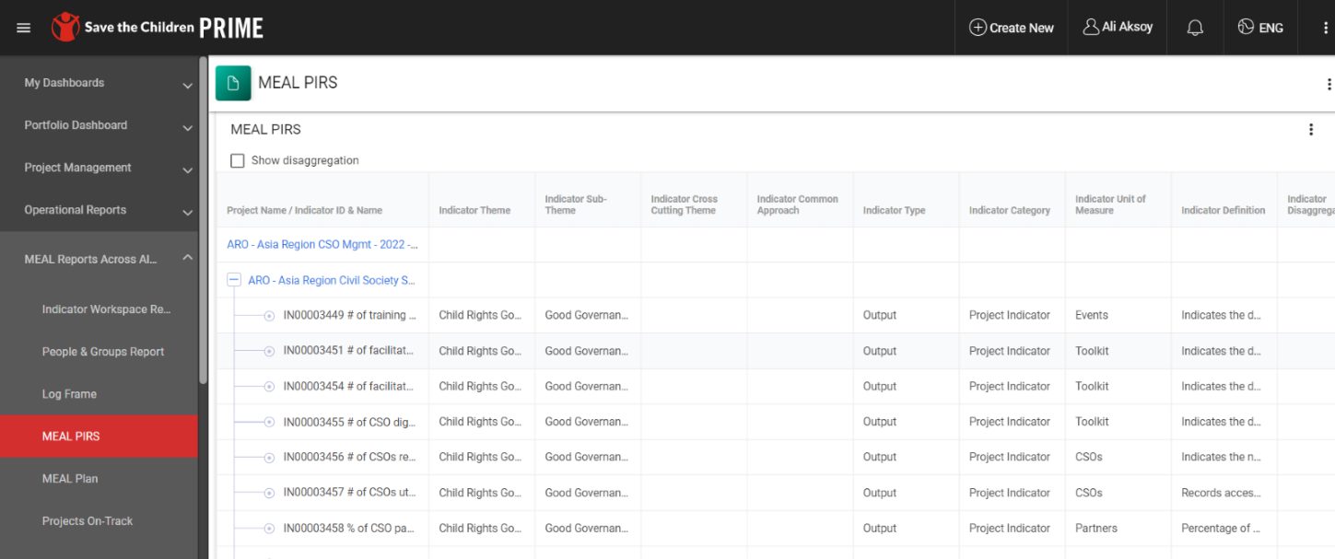
SCHP Indicator Codes (for Humanitarian only) - (Centralized Approach)
We think that the SCHP Indicator codes (see below table 1) can be a great starting point to pilot whether the linkages can be built through them, by referring to the codes or standard indicators throughout databases. In this case, the SoF codes can be utilized as a unique identifier to be tagged along with the SCHP Indicator codes (Table 2) – example OHT.W01.9990099. The following sections of this document uses this approach as an example due to its target audience of humanitarian MEAL teams.
SCHP Indicator | SCHP Indicator Code
Number of vaccines provided by SC supported facilities, mobile clinics or vaccination campaigns | OHT.H01
Number of patients who received inpatient or outpatient consultation at a supported health facility or mobile clinic (number of consultations) | OHT.H02
Number of maternal and reproductive health consultations provided at a supported health facility or mobile clinic (number of consultations) | OHT.H03
Table 1

Donor Codes (De-Centralized Approach)
We agree that not all country offices might find the use of such standard MEAL language necessary or relevant, or not have the resources to do so. Regardless, we suggest for country offices to create their own more simplified data points and coding to help out with the filtration within databases. Accordingly, we think donor indicator codes approach (e.g., BHA FCS01) can be used for such de-centralized KM approach, which later can be linked up with wider systems in global, as they still will have a certain reference point. In this case, we assume that the country office/s will likely not have a country framework or prioritized list of indicators, but still aim to manage things holistically without using a SCI common language.

Outputs | Indicators | Donor Indicator Code | SCHP Indicator | SCHP Indicator Code | Award SoF Code
Expected Output 1: Water Supply: Number of people having access to sufficient and safe water for domestic use | Number of individuals gaining access to basic drinking water services as a result of BHA assistance | W30 | Number of individuals directly reached through water, sanitation, or hygiene services | OHT.W01 | 9990099
Table 2

Project Management System of Save the Children

